**Held**

On

**1st May 2024** to **2nd May 2024**

At

**JSpiders/PSpiders, Hebbal**

**Report**

On

**Web Technology Workshop**

Submitted by

**Anjali Singh**

Student at

**Visvesvaraya Technological University**

**TABLE OF CONTENTS**

|  |  |  |
| --- | --- | --- |
| Sl. No | Contents | Page No |
| 01 | Summary | 01 |
| 02 | Introduction | 02 |
| 03 | Hands-on Sessions | 02 |
| 04 | Workshop Outcomes | 02 |
| 4.1 | Module 1 | 03 |
| 4.2 | Module 2 | 04 |
| 4.3 | Module 3 | 05 |
| 4.4 | Module 4 | 06 |
| 4.5 | Module 5 | 07 |
| 05 | Conclusions | 08 |

**SUMMARY**

The two-day workshop was held in the JSpiders/PSpiders Hebbal branch, Bangalore on 1st May 2024 to 2nd May 2024 to design some beautiful web pages. The workshop hosted by web Technologies trainers, brought together over 60 students. The workshop successfully utilized the enthusiasm and experience of the participants.

The workshop aimed to empower participants with practical skills in creating web pages.

The trainers provided guidelines and assistance throughout the workshop to ensure effective learning and development.

Each session had its own learning objectives and concrete outputs, which as the inputs for the following sessions:

**1st May 2024**

* Welcoming
* Addressing the participants about the sessions
* Detailed Explanation for the Project Design
* Project Idea Selection
* Initiation of the Project Structure

**2nd May 2024**

* Developing Project
* Hosting Project
* Documentation for the Project
* Photos Session
* Vote of thanks

Methodologically, the workshop employed an experiential learning approach, which allowed participants to engage themselves actively in the whole process through the selection of the idea for the project, creating the modules, linking all the modules together to hosting the project.

**INTRODUCTION**

The workshop commenced with an overview of web technologies, including HTML, CSS and JavaScript, highlight their significance in modern web development.

The workshop was interactive where we actively participated in discussions and exercises to reinforce our learnings.

The trainers were very supportive and was keep going helpings with all doubts and challenges faced by us.

They shared best practices to overcome common issues encountered during web developments.

**HANDS-ON SESSIONS**

We participants engaged in hands-on sessions, where we practiced coding HTML, CSS and JavaScript to build web pages. Trainer were readily available to address queries and provide support as needed.

We collaborated on projects to apply our newly acquired skills in real-world scenarios. Trainers provided mentorship and feedback to guide the teams throughout the project development process.

**WORKSHOP OUTCOMES**

I created a web page named as **“FleurFinesse”,** in which users will be able to visit website after the login only.

In this website total fives web pages I have created those are Index page to login, Home page, About page, Service page and Contact pages respectively.

I created basic structure of my website by using HTML and added CSS to style and layout our website to make it visually appealing.

As contents, I inserted images, videos and texts.

And created multiple pages and linked them to each other.

Tested and **hosted** on the website **“Netlify”**.

The all created pages are attached below:

**Module 1**

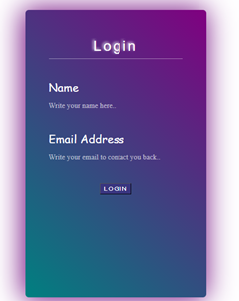

Login Page

These login pages created by using HTML and designed by applying the CSS properties such as background-color, hover, placeholder, Text-Shadowing, Box-shadowing etc. And to make functional it, I’ve used JavaScript’ elementary concepts. In this page user can login and visit the website.

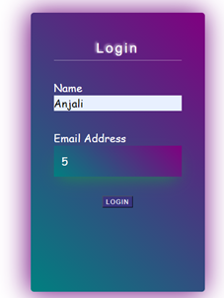

Login Page after inserting data

**Module 2**

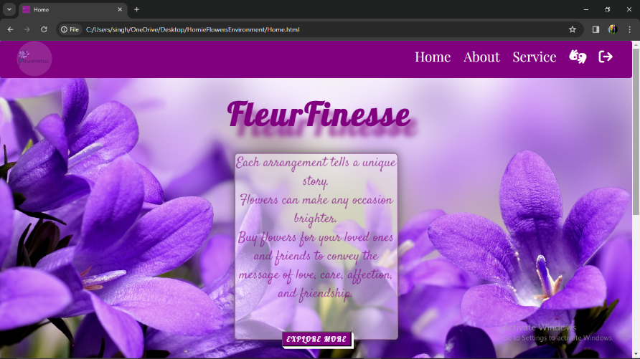

Home Page_1

This Home page structured by using HTML’s elements such as nav tag, list, paragraph, button and image and videos tag. And designed by applying the CSS properties such as background-color, hover, placeholder, Text-Shadowing, Box-shadowing etc.

On this page user can visit all pages by navigating the navigation bar and can see title “FleurFinesse” and descriptions about website.

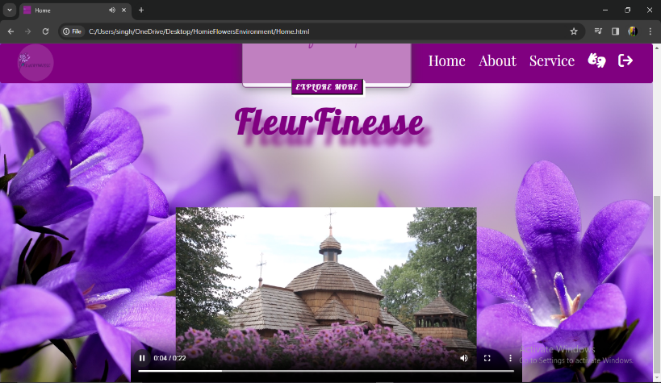

Home Page_2

**Module 3**

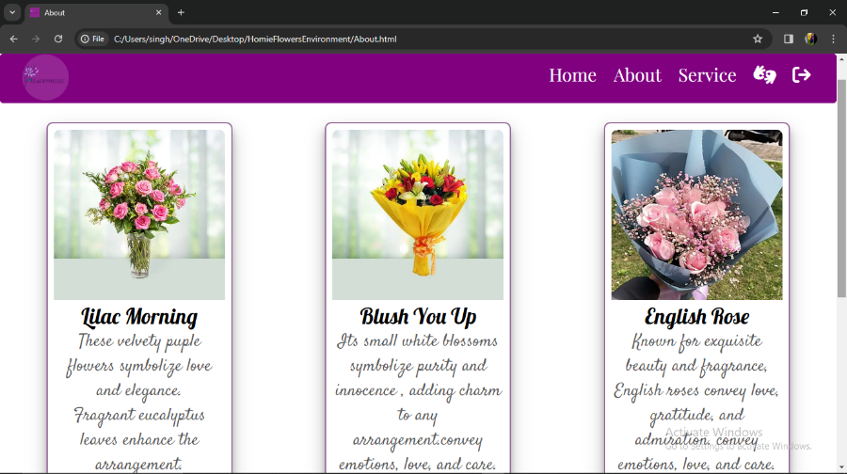

About Page_1

This About page structured by using HTML’s elements such as nav tag, list, paragraph, button and image and videos tag. And designed by applying the CSS properties such as background-color, hover, placeholder, Text-Shadowing, Box-shadowing, 2D and 3D effects scaling and translate etc.

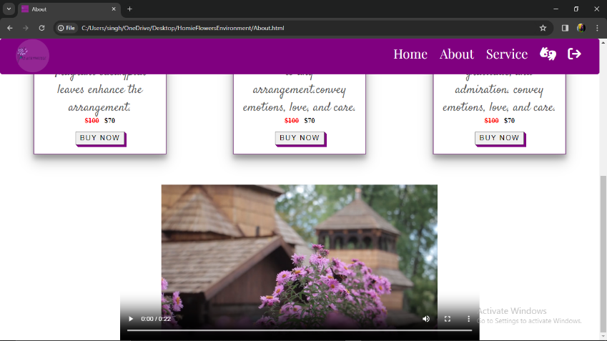

About Page_2

On this page user can visit all pages by navigating the navigation bar and can see the three card which user can hover, after hover images’ scaling will be changed and also the descriptions about particular card.

User also can play animation video.

**Module 4**

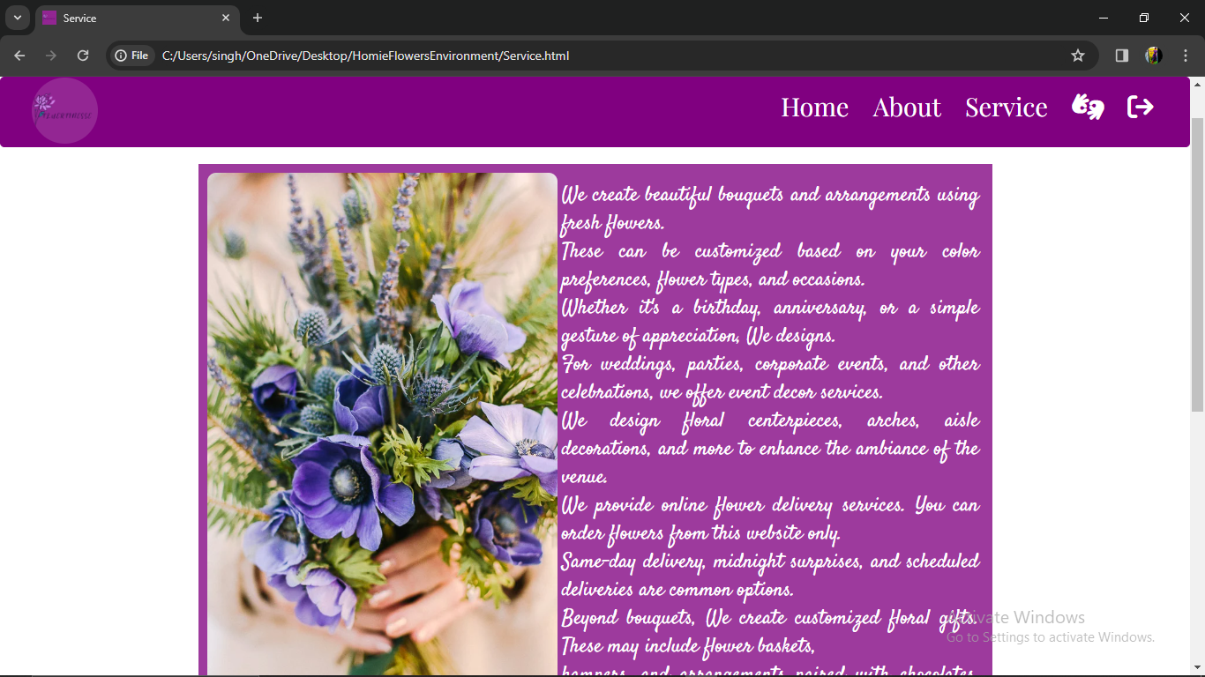

Service Page_1

This Service page structured by using HTML’s elements such as nav tag, list, paragraph, button and image and videos tag. And designed by applying the CSS properties such as background-color, hover, placeholder, Text-Shadowing, Box-shadowing etc.

On this page user can visit all pages by navigating the navigation bar and can be familiar with the type of services is provided by site “FleurFinesse”.

User also can read easily by hovering on the text.

|  |  |
| --- | --- |
|  |  |

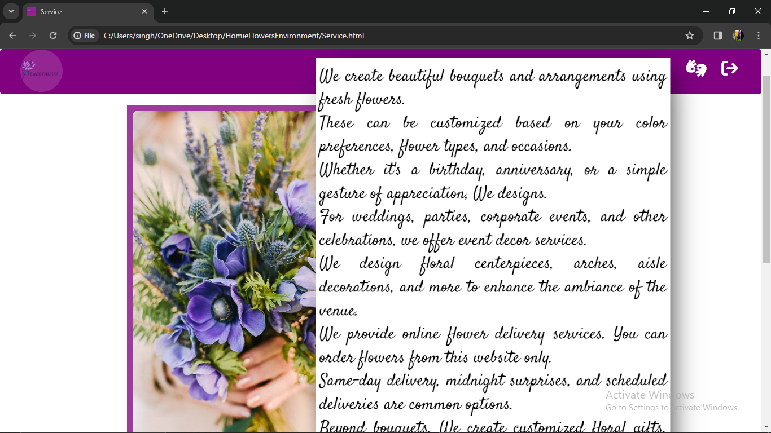

Service Page_2

**Module 5**

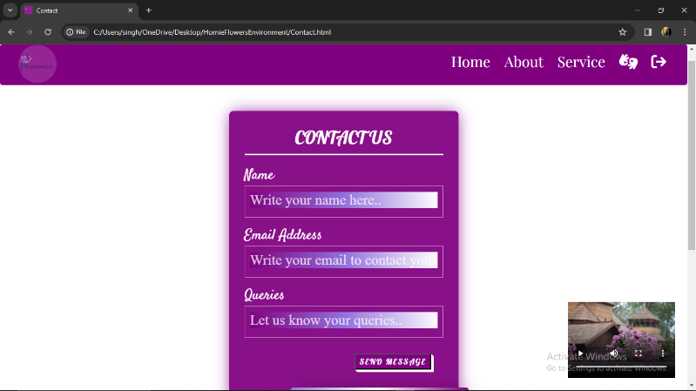

Contact Page_1

This Contact page also structured using HTML’s elements such as nav tag, list, paragraph, form, button and image and videos tag. And designed by applying the CSS properties such as background-color, hover, placeholder, Text-Shadowing, Box-shadowing etc.

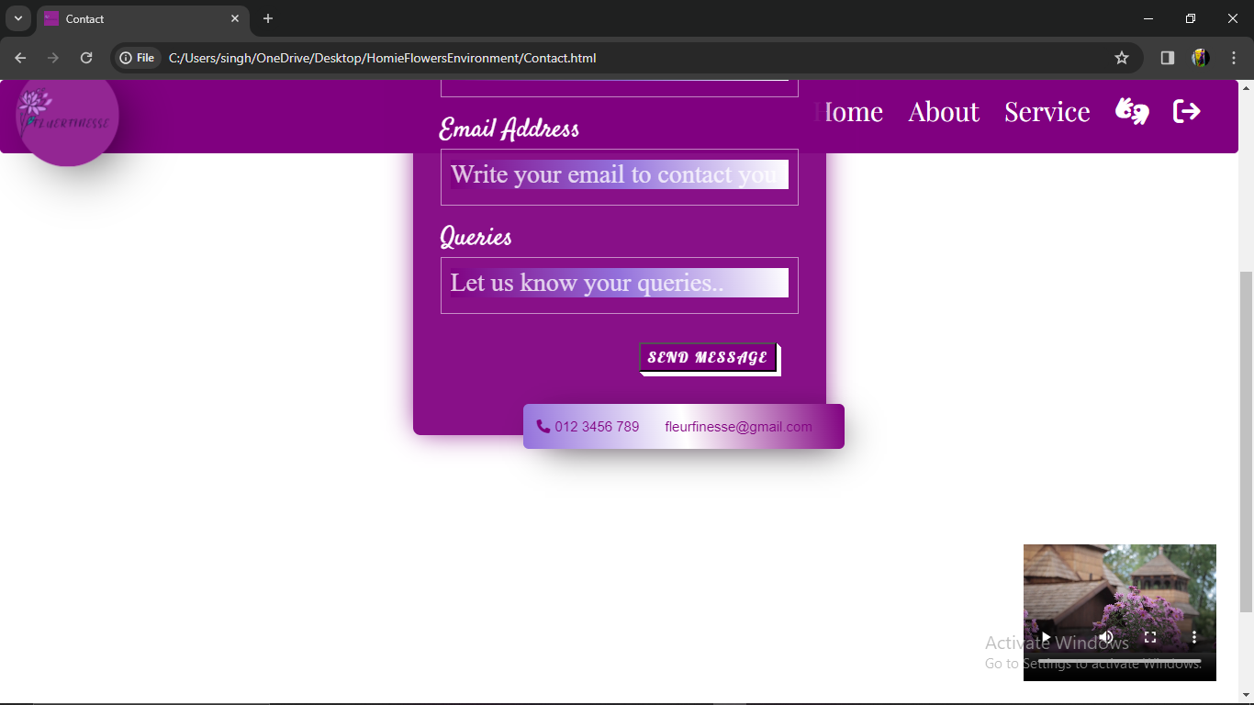

Contact Page_2

On this page user can visit all pages by navigating the navigation bar. User also can interact with us and they can write the queries by submitting the form.

**CONCLUSION**

The workshop was and empowering experiences with essential skills to create websites. With hands-on guidance practical insights, I gained a deeper understanding of web development. This workshop not only provided valuable knowledge but also inspired individuals to embark on ever-evolving realm of web design and development.